ASSIGNMENT A2

SECTION-1 (HTML assignments)

22. Create an empty directory ‘Assignments’ & cd to ‘Assignments’

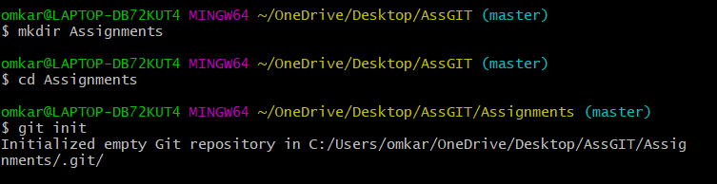

23. Create a file README.txt inside ‘Assignments’ & write few lines about the contents of ‘Assignments’ folder.

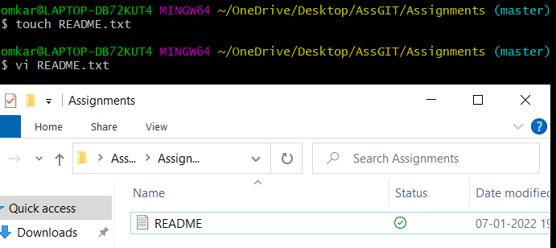



24. Commit README.txt file.

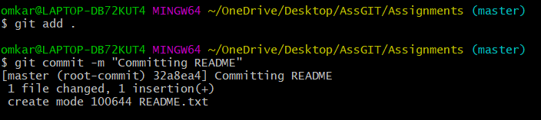

25. Now create a new branch ‘html-assignments’.



26. Switch to ‘html-assignments’ branch.



27. Copy all HTML assignments inside ‘Assignments’ folder.

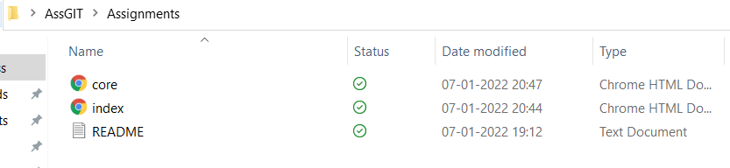

28. Commit HTML assignments into ‘html-assignments’ branch.

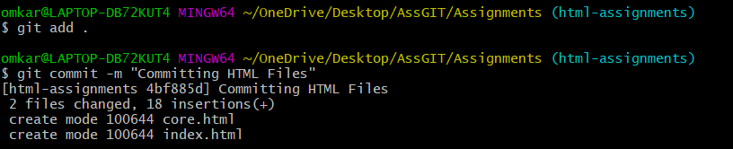

29. Make minor changes into few files belonging to ‘html-assignments’ branch.

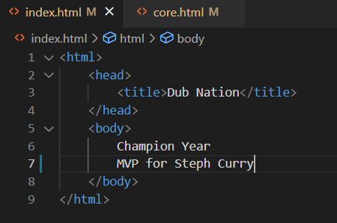

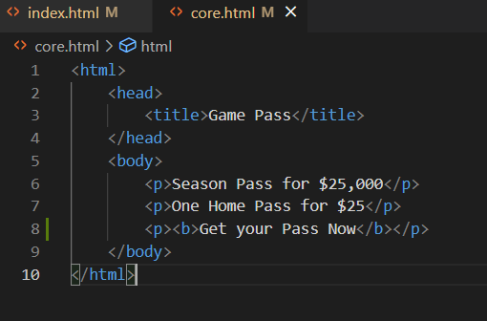

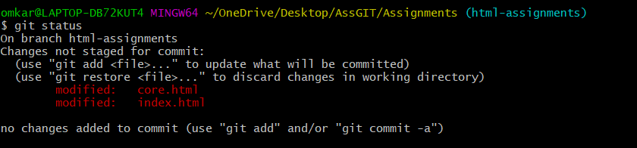

30. Commit those changed files

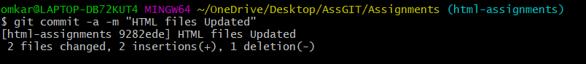

31. Switch to master branch.



32. Make minor changes into README.txt file & commit those changes into master

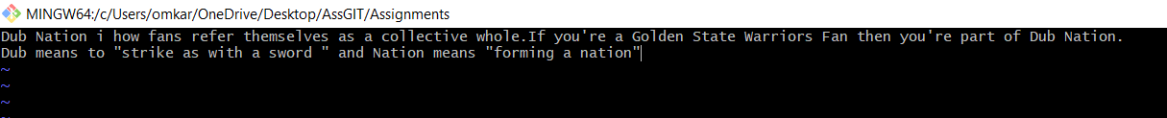

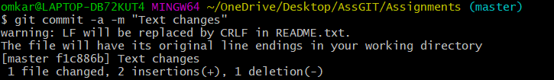

33. Again switch to ‘html-assignments’ branch.

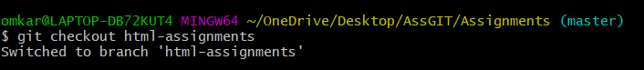

34. Make minor changes into few files belonging to ‘html-assignments’ branch.



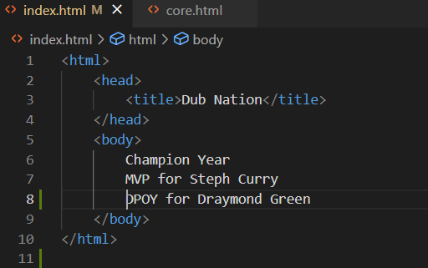



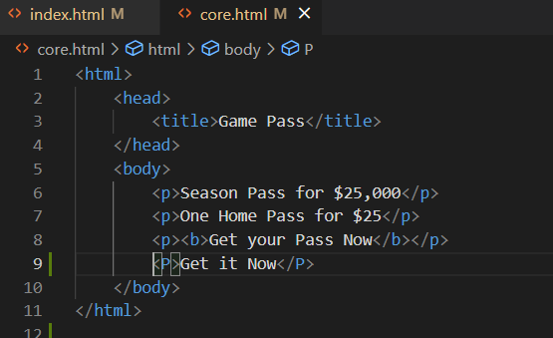

35. Commit those changes

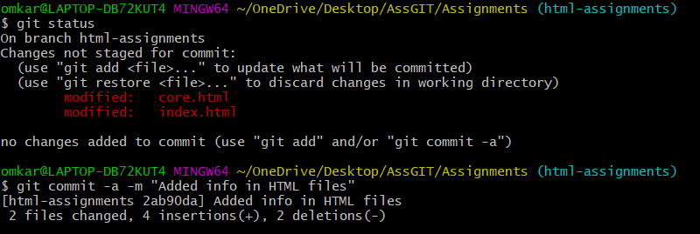

36. Switch to master.

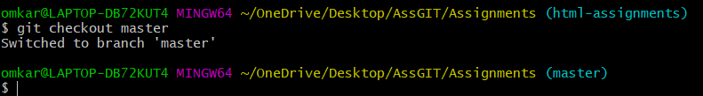

37. Merge ‘html-assignments’ branch into master. Confirm all html assignments are shown in master.

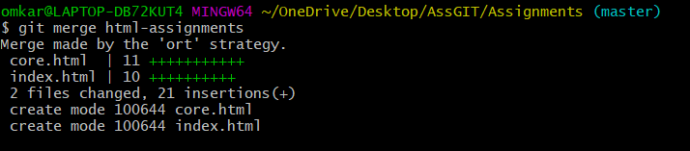

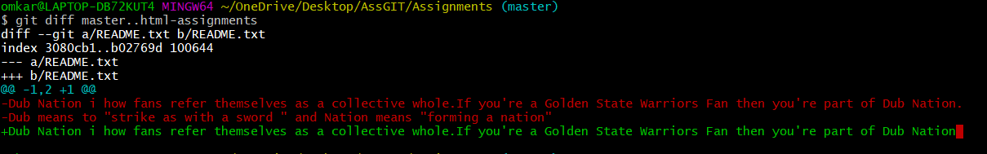

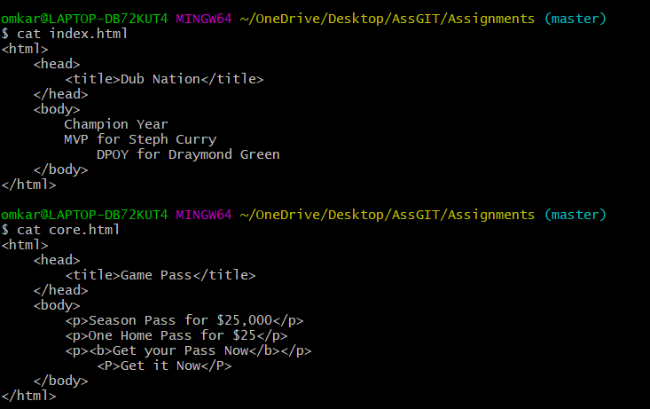

38. Finally delete the ‘html-assignments’ branch



SECTION-2 - (CSS assignments)

1. Create a new branch ‘css-assignments’.



1. Switch to ‘css-assignments’ branch.



1. Copy all CSS assignments inside ‘Assignments’ folder.

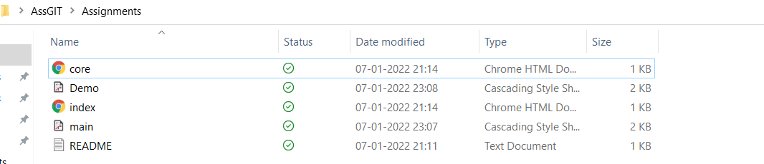

1. Commit CSS assignments into ‘css-assignments’ branch.

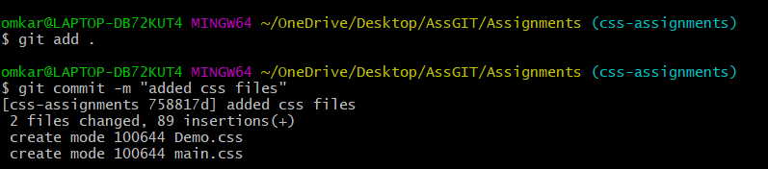

1. Make minor changes into README.txt file on line 1 belonging to ‘css-assignments’ branch.

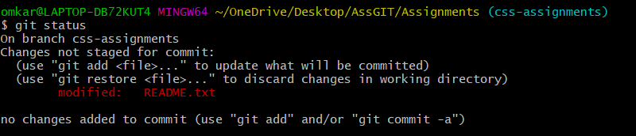

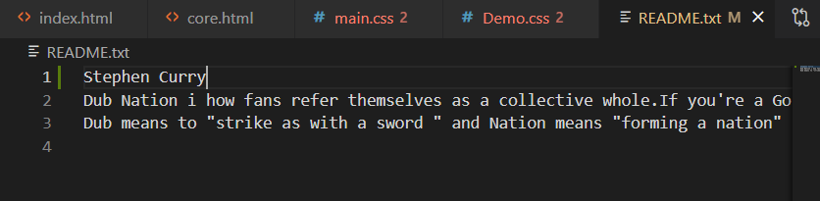

1. Commit those changed files.

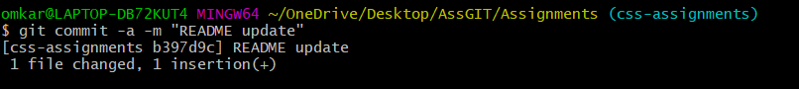

1. Switch to master branch.

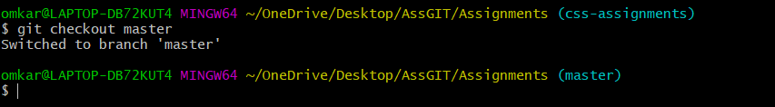

1. Make minor changes into README.txt file on line 3 & commit those changes into master

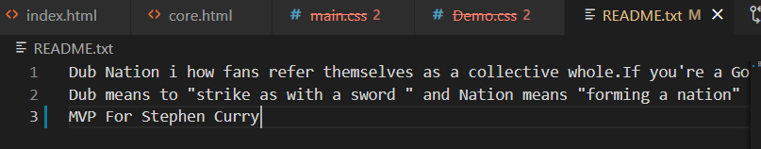

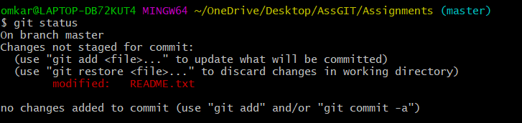

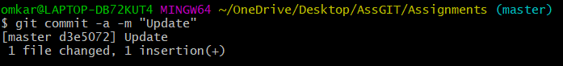

1. Again switch to ‘css-assignments’ branch.



1. Make minor changes into few files belonging to ‘css-assignments’ branch.

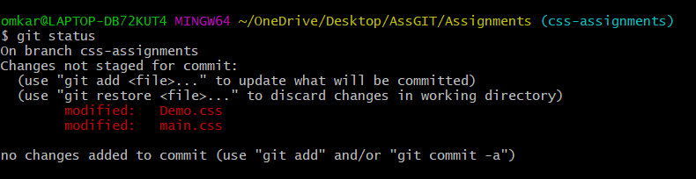

1. Commit those changes.

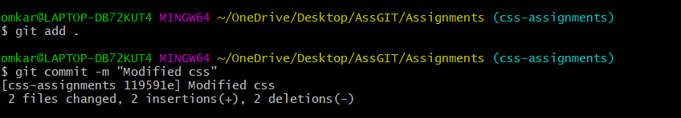

1. Switch to master.

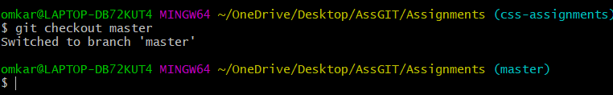

1. Merge ‘css-assignments’ branch into master. Confirm all css assignments are shown in master.

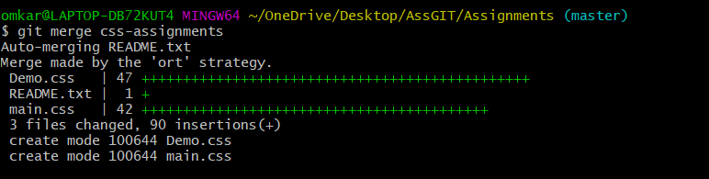

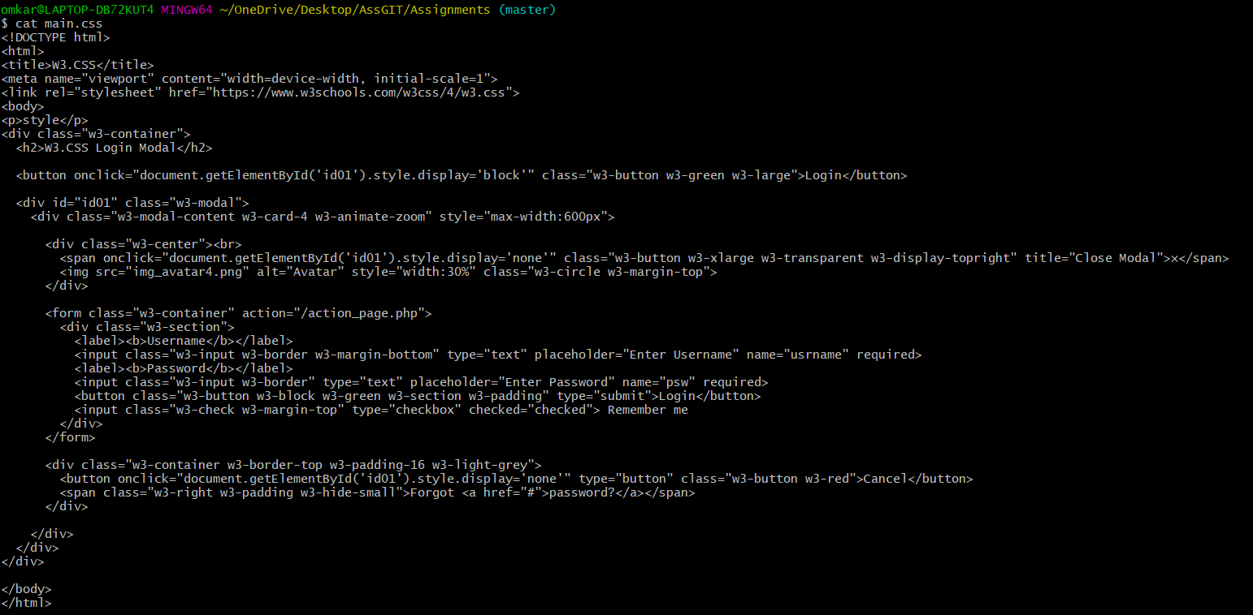

1. Finally delete the ‘css-assignments’ branch.



SECTION-3 - (JavaScript assignments)

1. Create a new branch ‘js-assignments’.



1. Switch to ‘js-assignments’ branch.

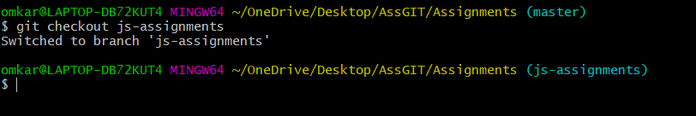

1. Copy all JavaScript assignments inside ‘Assignments’ folder

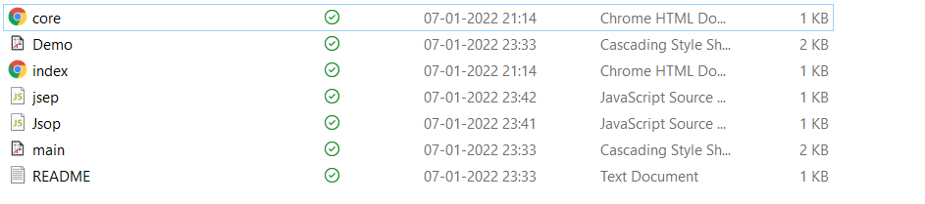

1. Commit JavaScript assignments into ‘js-assignments’ branch

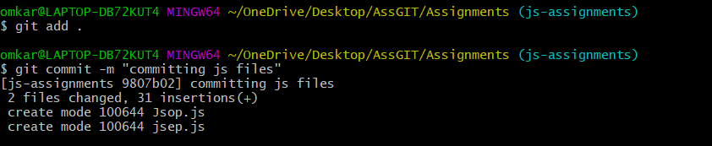

1. Make minor changes into README.txt file on line 1 belonging to ‘js-assignments’ branch.

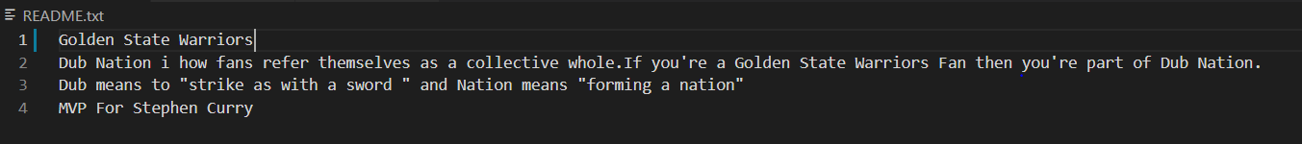

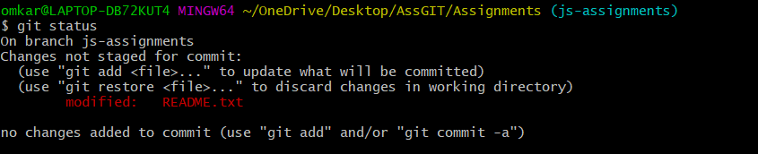

1. Commit those changed files.

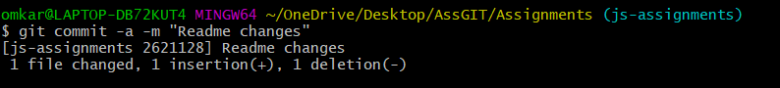

1. Switch to master branch.

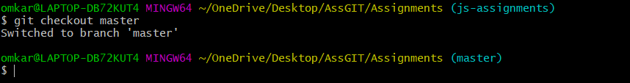

1. Make minor changes into README.txt file on line 1 & commit those changes into master.

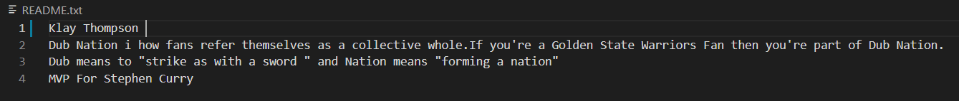

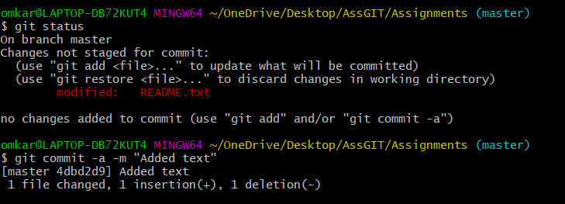

1. Again switch to ‘js-assignments’ branch.

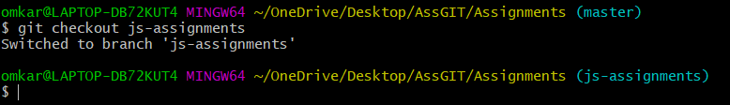

1. Make minor changes into few files belonging to ‘js-assignments’ branch.

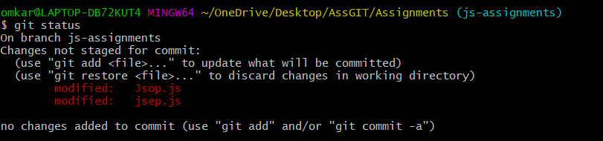

1. Commit those changes.

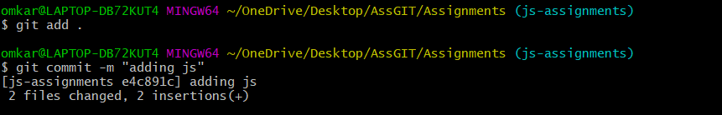

1. Switch to master.

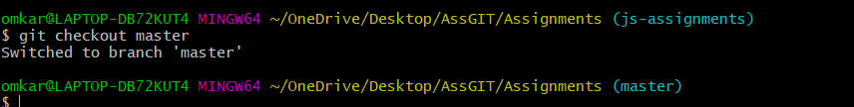

1. Merge ‘js-assignments’ branch into master. Confirm all JavaScript assignments are shown in master.

